Instructions for manuscripts submission for First CORDEX WRF

J.L. First¹, P.L. Second² and J.C. Third²

¹Department of Physical Chemistry, University of Somewhere, City, Region, Postcode, Country
²Department of Chemical Physics, University of Elsewhere, City, Region, Postcode, Country

Keywords: first, second, third, fourth.

Presenting author email: j.first@somewhere.edu

The abstract should be in double column (like this example). There is no limit for the manuscripts extension. Use A4 page set-up and make all margins (top, bottom, left, right) 20 mm wide. Start typing text about 7cm from the top of the page. Use 10 pt Times New Roman font (except for the title which should be in 12 pt bold and in sentence case). Centre the title, the authors’ names, the addresses, and keywords and contact email address. Please compose a title that clearly and succinctly describes the content of your work, in order to maximise its impact.
Start each paragraph, except the first, with an indent. Justify the body of the text both left and right. Do not use page numbers. Uniformity of manuscripts style makes the work much easier to digest! Please select appropriate keywords.
Use clear English to write your manuscripts, with an emphasis on describing what is new and why it should attract the attention of the audience.
Figures can be in colour or in black and white. Ensure that Figures and Tables have a caption and that they are numbered consecutively.

Table 1. Comparison between theoretical predictions and experimental measurements.
Month | Measured density (⎧g/m3) | Predicted density (⎧g/m3)
January | 0.4 | 121
June | 2.4 | 1.528⋅10⁴

References should be made in the style (Dickenson, 2005), Marr and Morrissey (2010) or as Curtis et al (1996). Examples of references are shown below. Leave a blank line above the list of references, and also above the acknowledgements.
Section headings can be used.

Manuscript review

The manuscripts will be reviewed by the chairs and co-chairs of the First CORDEX WRF. Manuscripts which do not fulfil the standards will be rejected. Please avoid submitting abstracts containing only future results.
The manuscripts should be submitted in pdf format through the First CORDEX WRF website. The deadline for manuscripts submission is 16 September 2012.

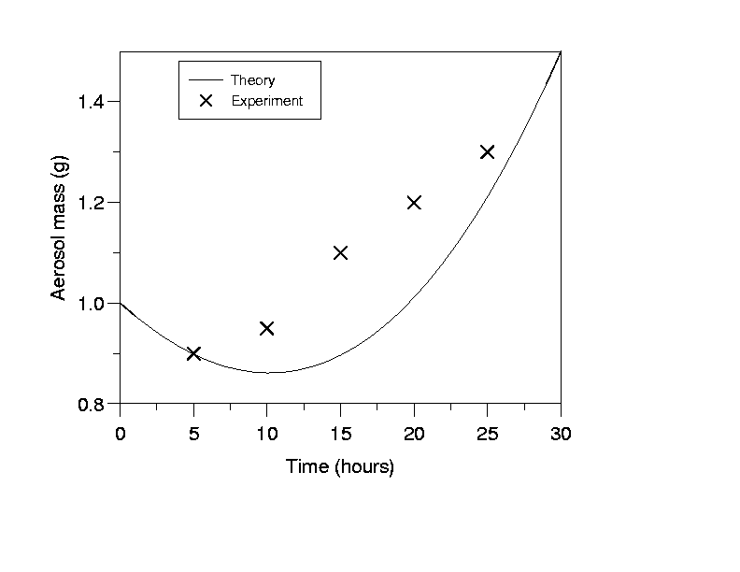

Figure 1. This is a comparison between theory and experimental data.

This work was supported by the National Council for Aerosol Research under grant JB/005.

Curtis, I., Hook, P., Morris, S. and Sumner, B. (1996) Proc. 2nd Int. Conf. on Aerosols in the Atmosphere, World Scientific.
Dickenson, B. (2005) Acoustic fragmentation of aerosol agglomerates, Manchester University Press.
Marr, J. and Morrissey, S. (2010) Phys. Rev. Lett. 210, 123-126.

